CSIS1175W16 AS1

In this assignment, you are required to code a program to help out **Douglas Cruise Line** to manage its cruise business. **Create a C# program with the name XxxxYyyy where Xxxx is your first name and Yyyy is your last name.** If you are working in a group (max 3 including yourself), just put down one member’s names as the project name. You will enter other members’ names in the source code as comments. You must use upper and lower cases for the project name.

Below is a screen capture of how your program should look like.

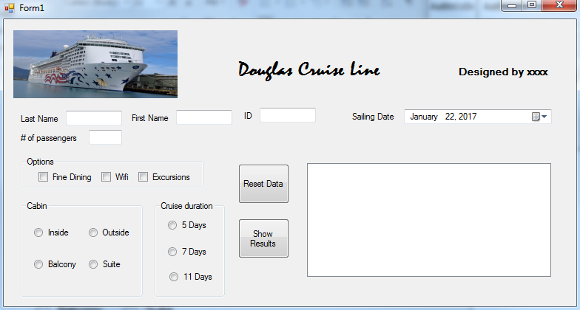

You need to replace xxxx (upper right hand corner) with your own name. If you are working in a group (max 3 including yourself in a group), everyone’s name must appear here. Please use upper and lower cases for your names. Marks will be given to those with the names shown only. **Each group needs to submit one program only. If two groups/students submit a similar program, both will be treated as cheating in assignment. Douglas College’s policy on academic honesty will strictly be enforced.**

Zip up your entire program from the top folder and submit it via Blackboard before 11:59:59pm on Feb 1st, 2017. Late submission will not be accepted. In your email subject line, you must put down: CSIS1175AS1 Winter 2017 Section x, where x is your section number. The name of your zip file must be the same as your project name. If you do not follow the above instructions, including the file name and subject line, you will get marks deducted.

If for whatever reason I cannot open or execute your program, you will receive zero in this assignment. This assignment carries 5% of your course grade. Your program must be done using Visual Studio 2015. Do NOT use any other version Visual Studio for this assignment at all.

At the beginning of your source code, you must again enter your section #, everyone’s name and student ID as a comment. You also have to comment your code to explain your logic like what we do in the class. You can refer to your textbook pages 102 for more details. You will lose marks if you do not provide sufficient comments to explain your code.

Please note that there are certain topics, such as the datetime picker for the cruise sailing date, have not been covered in the class. You can to surf the Internet to learn it on your own. In this assignment, you are not required to validate the user data entries. You can use the attached cruise ship picture for your picture box (upper left hand corner).

When your program first starts, all the textboxes must be cleared. There should be no selection of any check boxes and the radio buttons. The listbox must be empty. The sailing date (upper right hand corner) will be set to the system date (i.e. today’s date).

When the user clicks on the **Reset Data** button, your program will automatically initialize various controls with the follow default values:

***Default values from Reset Data***

|  |  |
| --- | --- |
| Last Name | Your own last name |
| First Name | Your own first name |
| ID | Your 9-digit student ID |
| Sailing Date | 10 days after the system date |
| Options | none |
| Cabin | Inside |
| Cruise duration | 5 Days |
| # of passenger | 2 |
| Listbox | blank |

User is allowed to change any of input values, including the sailing date and then click on the Show Results button to get the updated results.

The **Show** **Results** button will use the following cost figures to perform the necessary computations:

|  |  |
| --- | --- |
| Fine Dining | $50 per day per person |
| Wifi | $35 for 5 days, $40 for 7 days, $50.5 for 11 days, no relationship to the # of passengers |
| Excursions | $200 per person regardless of the cruise duration |
| Inside Cabin | $100 a day per person |
| Outside Cabin | $130 a day per person |
| Balcony | $200 a day per person |
| Suite | $350 a day per person |

**Interpretation of the results (shown in the listbox)**

Your listbox consists of 2 columns:

**Invoice number:** this number is formed using the contents of the corresponding textboxes --first letter of the last name, first letter of the first name, and last 5 digits of the ID. This invoice number must be in *upper case*. You should be aware that the user may not necessary enter the names in proper upper and lower cases. Take a look at the screen capture on Page 4 for details.

Number of passengers: from the corresponding textbox

Sailing date: from the corresponding textbox

Ending date: sailing date + cruise duration

Cabin amount: based on the above cost data

Fine dining amount: based on the above cost data

Wifi amount: based on the above cost data

Excursion amount: based on the above cost data

Blank line: separating the individual amounts and the total amount

Total amount: sum of the above amounts

Take a closer look at the following screen captures for details.

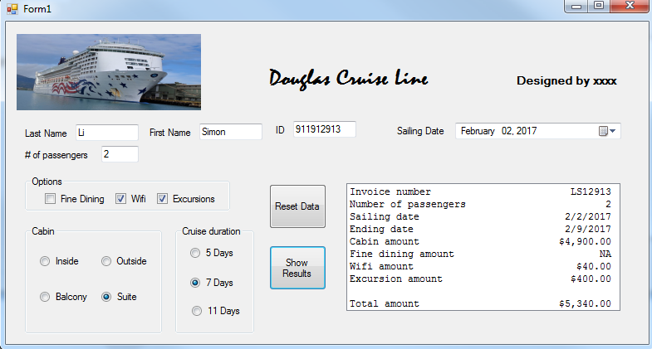

Note that the following screen capture below shows an appropriate message when no option is selected and the customer names are entered in lower case.

